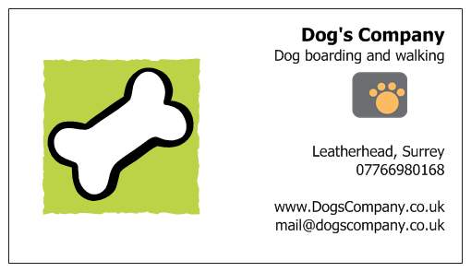

Service Agreement

Your dog must be microchipped and have a tag on its collar with the correct details.

Your dog should be insured at least third party.

Inform us of recall/behavioural/aggression issues.

Your dog should be up to date with vaccinations, flea and worm treatments.

You will provide all food required for the entire duration of your dog’s stay.

If your dog causes injury to another dog whilst in our care, you will be asked to pay the insurance excess.

We are fully insured including public liability, but cannot be liable for any vet bills.

The information provided to us is true to the best of your knowledge and belief.

When you sign this form you give consent to your dog/s interacting/sharing with other dogs for boarding/daycare.

You also give consent to the use of a crate if needed/necessary.

If your vet is within our designated pick up/drop off area then we will endeavour to take your dog/s to their own vet if necessary, otherwise it will be to our registered vet, Cobham Park Veterinary Clinic.

If you agree for your dog to be let off the lead while being walked by Dog’s Company, then any accident or injury caused by your dog whilst off the lead will not be our responsibility or liability. We will not let your dog off the lead unless authorised by you. Please circle.

Signature_________________________________________________Off Lead____On Lead

Name______________________________________________________________________

Date_______________________________________________________________________

Phone Numbers______________________________________________________________

By providing us with your information you have agreed to allow us to contact you via email, text or post regarding Dog's Company business. We will not pass on your information to anyone.

